CS2210 Data Structures and Algorithms – Second Concept Assignment
Name: Dhruwang Kishorbhai Akbari
Student No. 251186352
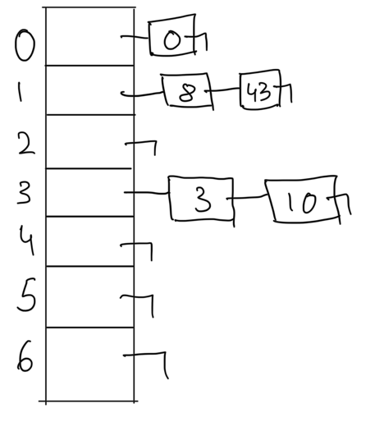
Q1.

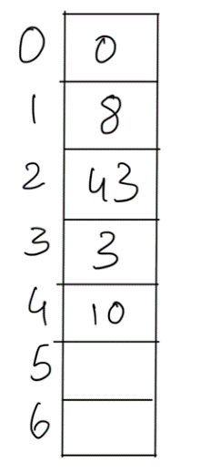
Q2.

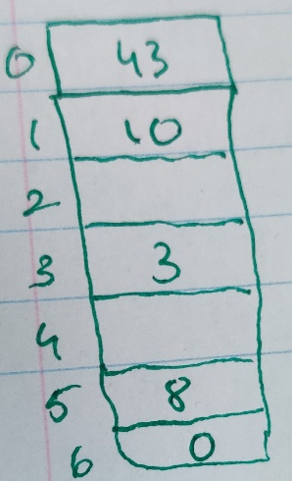
Q3.

Q4. Solving the recurrence equation
$$f\left(0\right)=c_{0}$$
$$f\left(n\right)=f\left(n-2\right)+c_{1}n+c_{2}$$
$1. f\left(n\right)=f\left(n-2\right)+n$ (we can remove the constants from the equation so we are left with n
$f\left(n-2\right)=f\left(n-4\right)+(n-2)$ now we substitute this equation to 1
$$2. f\left(n\right)=\left(f\left(n-4\right)+\left(n-2\right)\right)+n$$
$f\left(n-4\right)=f\left(n-6\right)+\left(n-4\right)$ Now we compute and we substitute in equation 1
$$3. f\left(n\right)=(f\left(n-6\right)+\left(n-4\right))+\left(n-2\right)+n$$
Now we repeat these steps of substituting for ‘k’ times
$$4. f\left(n\right)=f\left(n-k\right)+\left(n-\left(k-2\right)\right)+\left(n-\left(k-4\right)\right)+…+\left(n-1\right)+n$$
Now that we have reached n = k, we substitute the value of k in equation 4
$$5. f\left(n\right)=f\left(n-n\right)+\left(n-n+2\right)+\left(n-n+4\right)+…+\left(n-1\right)+n$$
$$6. f\left(n\right)=f\left(0\right)+2+4+…+(n-1)+n$$
$$7. f\left(n\right)=c_{0}+\sum_{i=2}^{n}{i}$$
When we solve the summation we get $n\left(n+1\right)$
$$8. f\left(n\right)=c_{0}+n\left(n+1\right)$$
Now removing the constants we get the time complexity as O(n²).

